Employer Brand Ambassador
Campus & Community Partnership Builder
Equity & Access
Advocate Program Architect & Experiential
Learning Designer

Program Operator

Recruiter
Student Experience & Development Champion

Internal Talent Consultant
Financial Steward

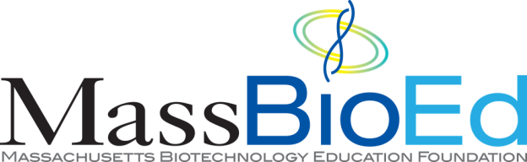


Workforce Strategist
Early Talent Recruiting

Data Analyst & Storyteller

Workforce Strategist Internal Talent Consultant
Recruiter

Employer Brand Ambassador

Campus & Community Partnership Builder

Equity & Access Advocate

Program Architect & Experiential Learning Designer
- Forecasts future talent needs based on business growth and skill demand
- Aligns early talent programs to long-term workforce strategy
- Coaches managers on role design and student scope
- Advises on which early talent pathway fits best
- Sets expectations for meaningful student experiences
- Screens, assesses, and selects candidates
- Designs and runs interviews and interview days
- Manages offers, acceptance, and hiring outcomes
- Brings company mission, culture, and science to life for students
- Represents the organization authentically on campus and online
- Differentiates the employer in competitive talent markets
- Builds long-term relationships with colleges, universities, and community partners
- Collaborates on recruiting strategy, events, and pipelines
- Maintains trust and continuity year over year
- Expands access to life sciences careers
- Partners with institutions focused on equity
- Designs programs that reduce barriers to entry
- Designs program structure, timelines, and experiences
- Creates toolkits, templates, and scalable processes
- Evolves programs based on outcomes and feedback


  - Manages timelines, onboarding, compliance, and coordination
Program Operator
  - Ensures students and managers are set up for success
  - Troubleshoots issues in real time
  - Ensures students receive mentorship and development
Student Experience & Development Champion
  - Builds professional development and career readiness experiences

  - Owns and manages program budgets (interns, co-ops, fellows)
Financial Steward
  - Advises leaders on cost, ROI, and tradeoffs across programs
  - Balances equity, access, and business constraints
  - Tracks participation, conversion, diversity, and outcomes
Data Analyst & Storyteller
  - Analyzes trends across schools, programs, and cohorts
  - Uses data to evolve strategy, justify investment, and define success

